Progress Report of Lucknow ISOPARB (2019-2021)
Present office bearer took charge in April, 2019 with new committee as follows:
President- Dr. S. P. Jaiswar
Secretary- Dr. Amita Pandey, Dr. Ajay Kumar, Dr. Deepali Shrivastav
Tresurer- Dr. Jyotsana
Joint Treasurer- Dr. Shuchi
- Academic activity as CME on Infertility and IUGR was conducted on 9.11.2019. Dr. Arveen Vohra from Bengaluru delivered lecture on Poor Responders. Dr. Radhika, Dr. Ajay Kumar and Dr. Jyotsana from Lucknow took lectures on various related topics. Along with Dr. Chandravati, Dr. Vinita Das and other eminent Gynecologists and Pediatricians from city attended and appreciated the CME. Total numbers of participants were 65.

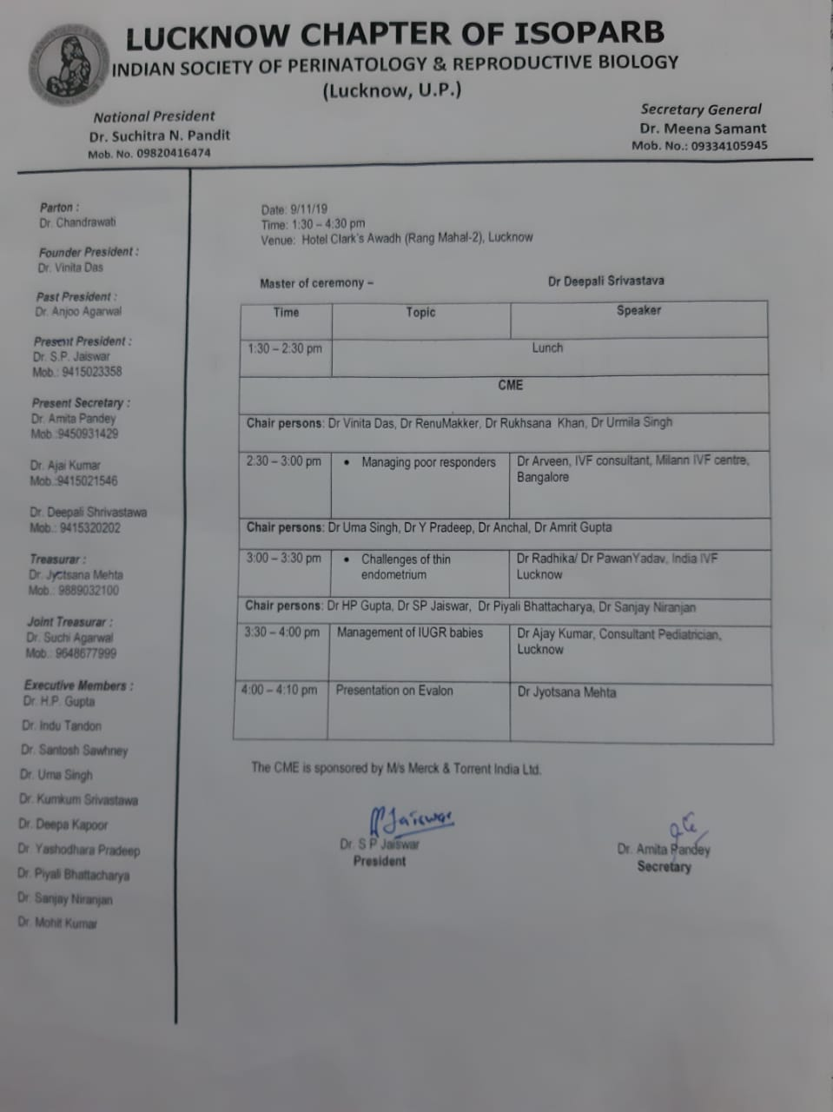
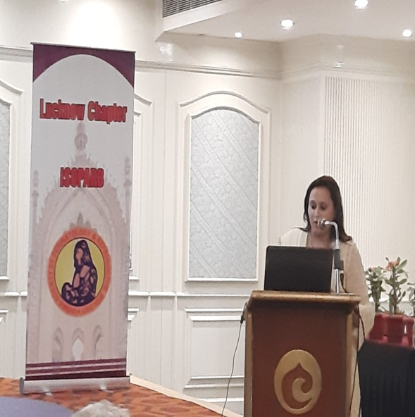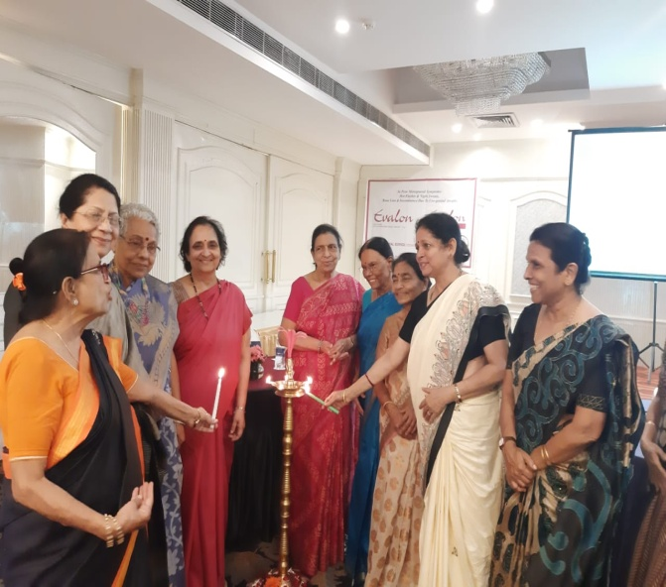
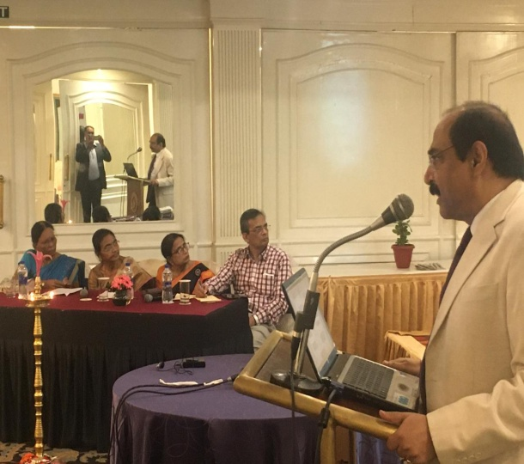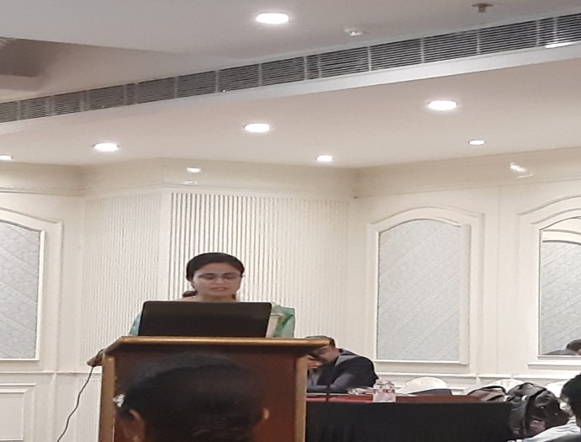
CME on Infertility and IUGR on 9.11.2019

- ISOPARB PG quiz was organized on 18.12.2019 on Maternal Infections during pregnancy at Oueen Mary’s Hospital of KGMUniversity, Lucknow. Dr. Astha and Dr. Shefali were selected and will be send for Zonal quiz on 6th February 2020 at Delhi.
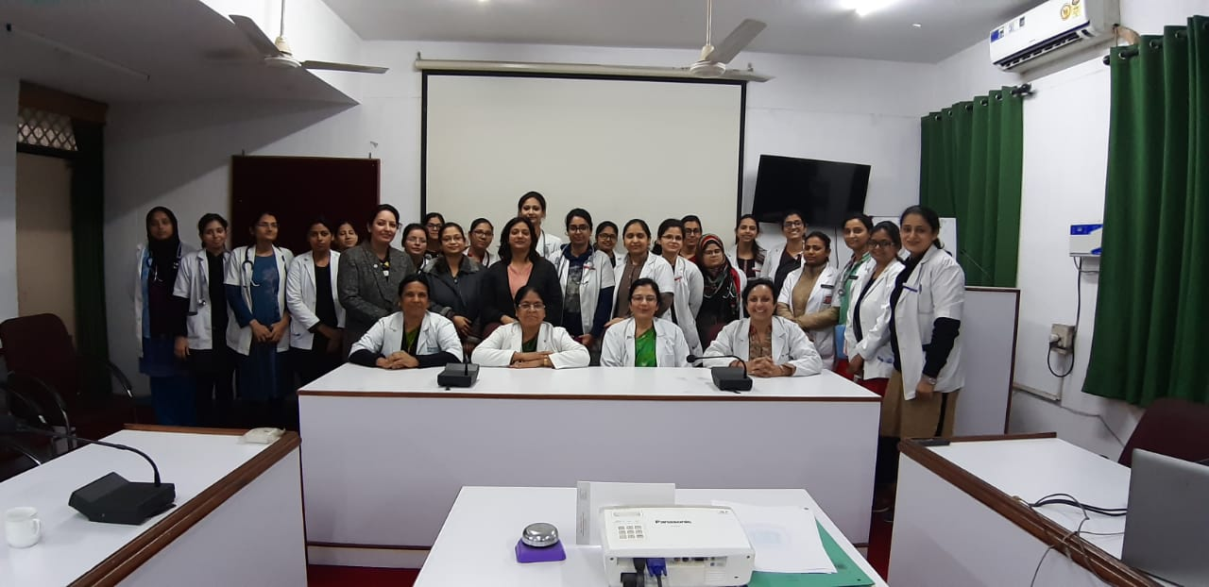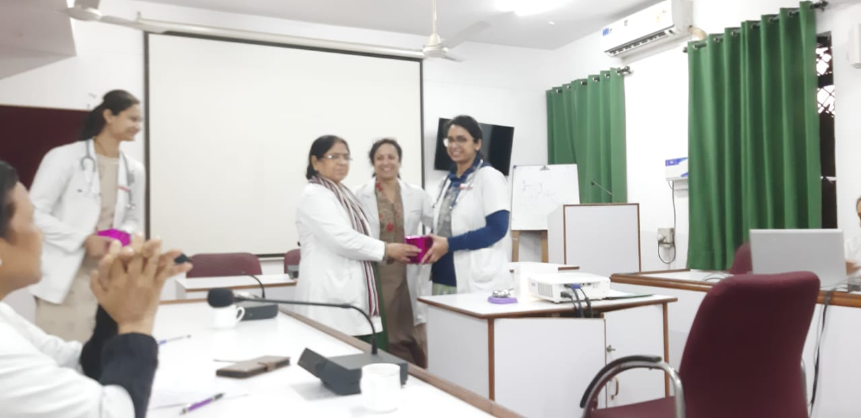

- An outreach camp in village Ghurakhpurva was conducted on 21.12.2019 under the aegis of ISOPARB in collaboration with NGO- NAI RAHEIN. 65 ladies and girls had come for consultation. Iron, calcium and multivitamins were distributed to the needed ones and consultation was given by Dr. Deepali Shrivastav.

